**DAILY ONLINE ACTIVITIES SUMMARY**

|  |  |  |  |  |  |  |  |
| --- | --- | --- | --- | --- | --- | --- | --- |
| **Date:** | **27/06/2020** | | | | **Name:** | **Syed Rabeya Aamir** | |
| **Sem & Sec** | **8th B** | | | | **USN:** | **4AL16CS112** | |
| Online Test Summary | | | | | | | |
| **Subject** | | **__** | | | | | |
| **Max. Marks** | | **__** | | **Score** | | **---** | |
| Certification Course Summary | | | | | | | |
| **Course** | **INTRODUCTION TO INFORMATION SECURITY.** | | | | | | |
| **Certificate Provider** | | | **Great Learning** | **Duration** | | | **5.5 hrs** |
| Coding Challenges | | | | | | | |
| **Problem Statement:**  **1)**  Python program to swap first and last element of a list. | | | | | | | |
| **Status: Solved** | | | | | | | |
| **Uploaded the report in Github** | | | | **YES** | | | |
| **If yes Repository name** | | | | **rabeya** | | | |
| **Uploaded the report in slack** | | | | **YES** | | | |

**Certification Course Details:**

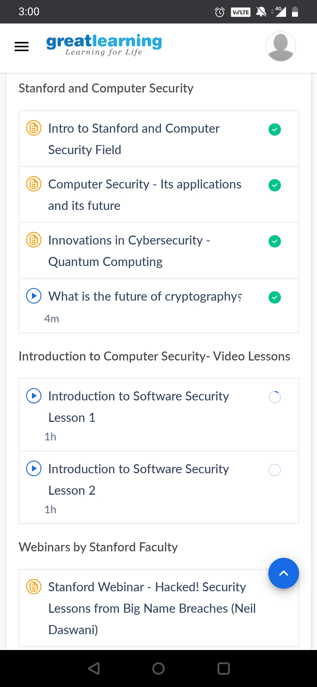

* From e-mail to cellular communications, from secure Web access to digital cash, cryptography is an essential part of today's information systems.
* Cryptography helps provide accountability, fairness, accuracy, and confidentiality. It can prevent fraud in electronic commerce and assure the validity of financial transactions. It can protect your anonymity or prove your identity.
* It can keep vandals from altering your Web page and prevent industrial competitors from reading your confidential documents.
* And in the future, as commerce and communications continue to move to computer networks, cryptography will become more and more vital.

# CODE:

Program no:1

# Python program to swap first and last element of a list

# Swap function

def swapList(newList):

size = len(newList)

temp = newList[0]

newList[0] = newList[size - 1]

newList[size - 1] = temp

return newList

newList = [12, 35, 9, 56, 24]

print(swapList(newList))